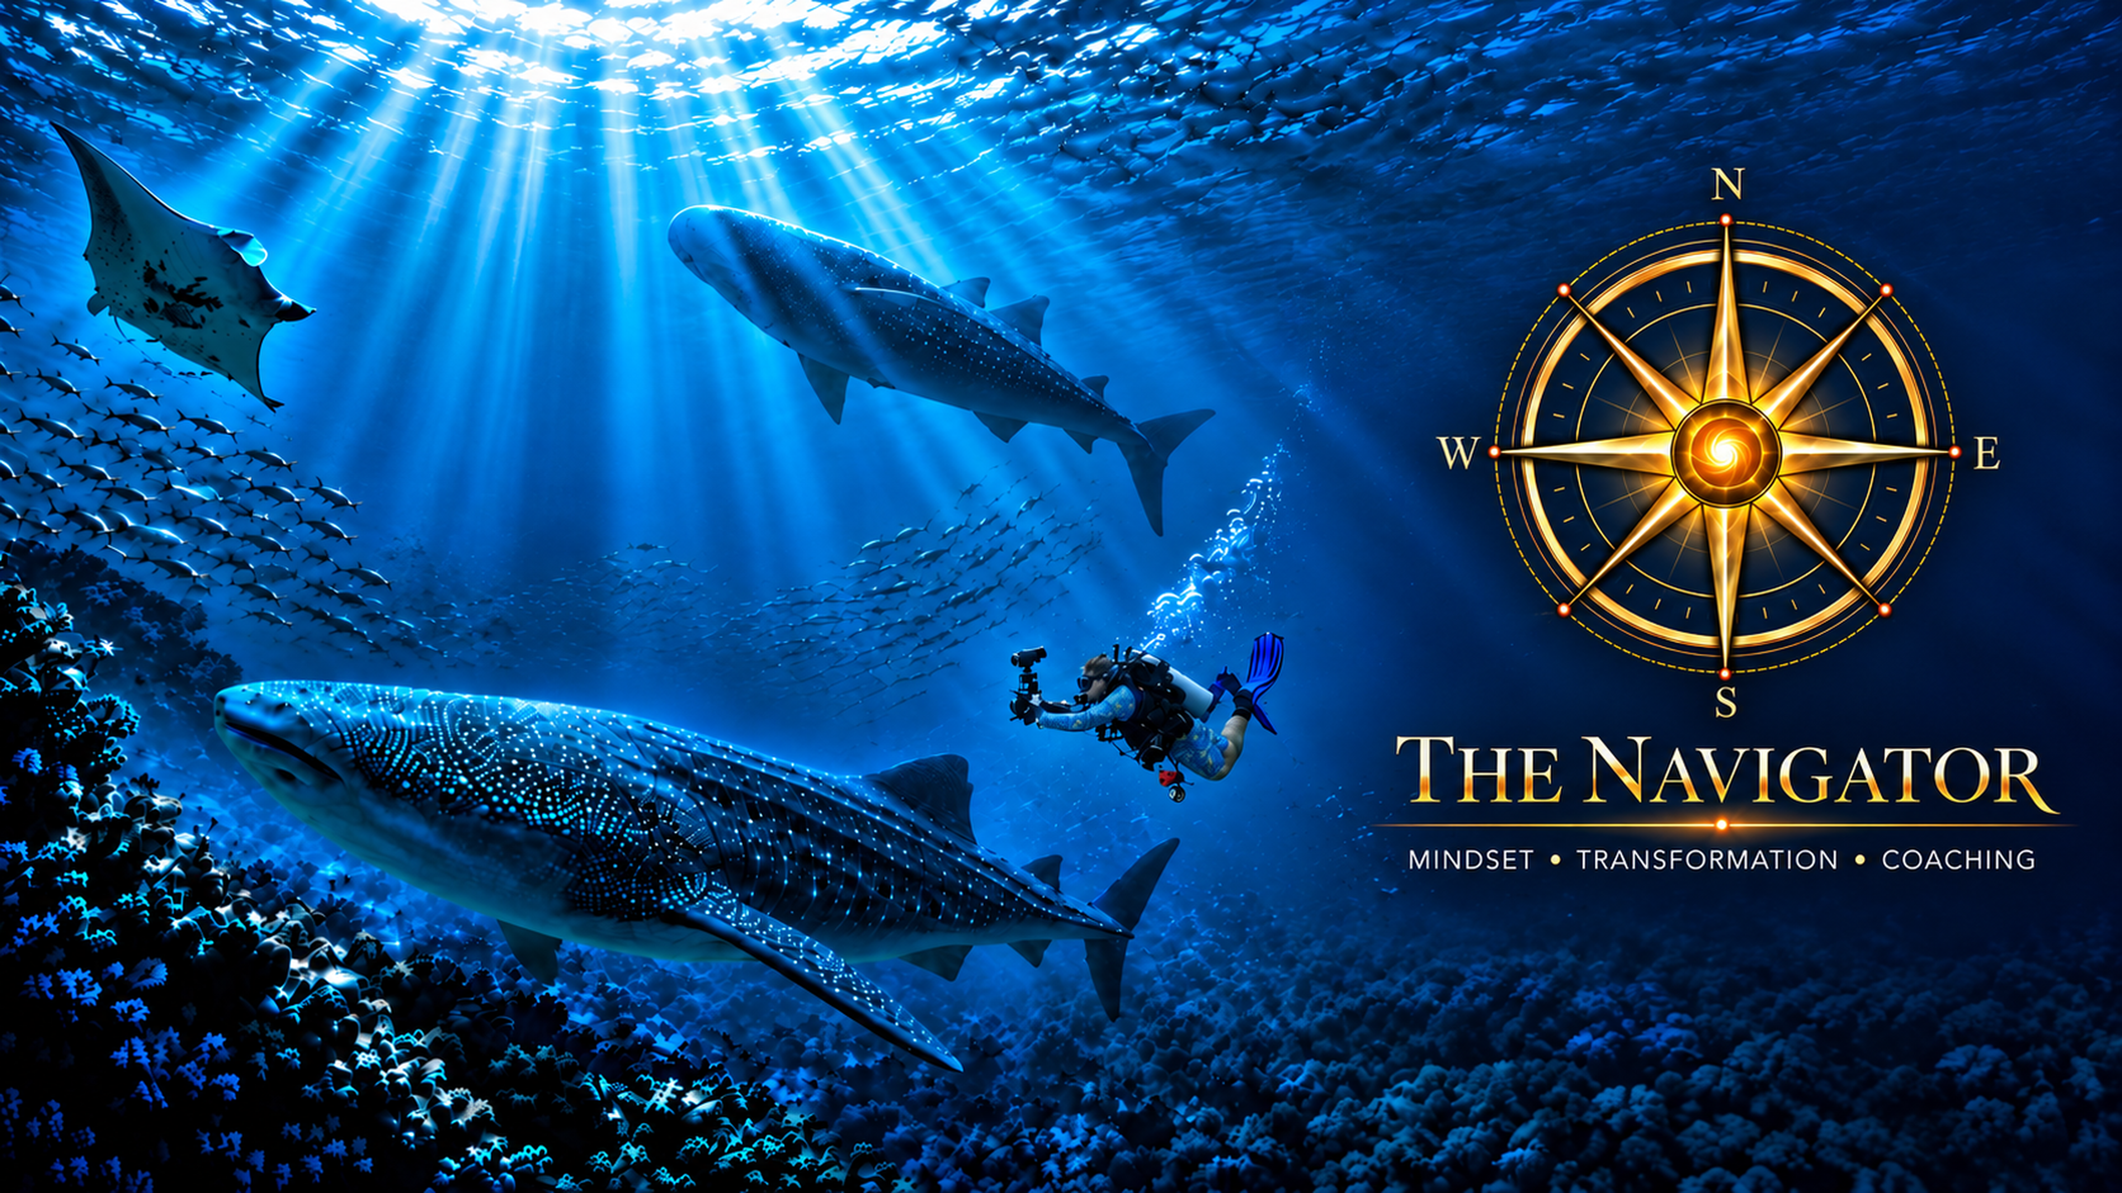
THE NAVIGATOR

Oshim Somers profile
Coaching workshops and retreats
Personal profile and journey
Name Oshim Somers
Email oshim@oshim.com
Phone +61 431 633 375
13 October 2026

The journey behind The Navigator

Finding clarity within complexity
The Navigator brings together different parts of Oshim Somers’ life: his work with people and organisations through complex change, his creative life, his connection with the ocean, and the personal challenges that have made finding direction a daily practice.
His interest is in how people make their way when familiar answers no longer seem enough. What matters now? What needs to change? What can remain? Where is there room to begin again?
Across his professional life, Oshim has worked in business transformation, technology, programme and project delivery, and financial and commercial environments. His own account of that work returns to listening, building trust, seeing patterns and connecting people with practical possibilities. A plan becomes useful when it makes sense to the people who must live with it. A system becomes valuable when it helps people participate.
That perspective now informs The Navigator. Alongside a structured approach to reflection and action is a willingness to meet someone in the life they are actually living, with its strengths, contradictions, commitments and uncertainty.

A life shaped by more than work
The December 2023 Dive Log Australasia feature by Steve Jones, “Limitless by Name”, describes a relationship with the ocean that began with fear and curiosity. Growing up in apartheid South Africa, Oshim faced segregated beaches and limited opportunities to learn to swim. At Tinley Manor Beach, a pair of goggles from his father helped him begin looking beneath the surface of the rock pools. Small fish and crabs opened a world he would continue wanting to explore.
His family moved to Australia in 1972 and settled in Port Pirie. Later, studying in Adelaide, he encountered the university dive club and took the step of learning to dive. He also helped the club secure resources, including equipment and a boat. A Super-8 camera went underwater with him, giving him early footage to share with his parents.
Adult life and family responsibilities took diving into the background for a period. The feature records his return in 2017, following contact with his long-time mentor John Bent. That return eventually led him into the tropical waters of the Philippines and into the film that would help him share a more personal story.
Work is one part of the story. In his writing, Oshim describes being shaped by family, friends, migration, belonging, ambition, leadership and creativity. Photography and filmmaking have given him ways to observe closely and communicate what ordinary language can sometimes miss. Music, soundscapes, travel and nature have also contributed to his sense of connection and meaning.
That creative thread reaches back to his father, a teacher and artist who recorded family life and travel on 8mm film. Oshim grew up watching those moving images preserve adventures, migration to Australia and life in country South Australia. His father’s example helped him learn to look through a camera, in still images and in motion, and to recognise how a picture can carry a memory forward.
Oshim’s early relationship with diving grew alongside that love of photography and travel. Being near the water, aboard a boat or beneath the surface became a calming and energising part of his life. Over time, underwater photography and short films gave him ways to share what he encountered there.
The ocean holds a particular place. Beneath its surface, he has found an environment that asks for attention, respect and presence. He calls that underwater world the blue cathedral: a place of reef walls, sunlight, movement and immense space.
There, the story carried at the surface can take on a different proportion. The ocean does not erase illness, fear or disappointment. In his account, it offers a reminder that his life belongs within something larger, and that he can remain present without needing to control everything around him.
This is why the compass and the ocean appear throughout The Navigator. They come from a relationship with place and a continuing search for direction.

Limitlessness in the Aquasphere
That connection took a deeply personal form in his film, Limitlessness in the Aquasphere. Filmed in the Philippines, it follows his exploration of diving, mindfulness and life after a Parkinson’s diagnosis, with manta rays, caves and sharks forming part of the underwater world around him.
In his account of making the film, Oshim says it began as something for close family and friends. He wanted to share how he really felt about Parkinson’s, beyond the brave face he had sometimes shown. He wanted those he loved to see the life he was experiencing beneath the surface, alongside the reality of the diagnosis.
The film grew through the people he met. Dive guides and boat crew helped capture the journey, and their care and support became part of its making. As he edited it, listening repeatedly to his own reflections gave him another way to consider what he was learning.
His father also lived with Parkinson’s. Reflecting on the film, Oshim remembered that his own memories of his father held a full, adventurous life. This helped him see that a diagnosis need not become the whole story by which someone is remembered.

When the journey became personal
Living with Parkinson’s and undergoing deep brain stimulation, or DBS, brought that search into a more intimate setting. The person who had helped navigate complex programmes was also having to negotiate change within his own body and everyday life.
In his September 2026 prologue, Oshim writes that DBS did not cure him of Parkinson’s or return him to the person he had been. He describes a quietness within the storm, a space in which he could begin listening differently. He also writes openly about frustration as he worked towards walking in a way that felt comfortable again.
His account leaves room for the difficult days. Adaptation takes time. Some changes remain. The horizon may look different from the one he once imagined. Hope, in this setting, involves staying open to possibilities while recognising the life that is here now.
These experiences have deepened his interest in dignity, participation, practical support and the space people need to find their own way forward.

Remembering a return that once seemed impossible
Parkinson’s and DBS are part of a longer history of adversity. Years earlier, severe chest infections and violent coughing led to broken ribs and a lung injury. In his writing, Oshim remembers hospital stays in which pain and the next breath occupied much of his attention. Returning to diving felt remote.
There was another period of chest illness and fractured ribs later. Recovery unfolded gradually. Eventually, he did return to the underwater world.
He remembers entering the blue again, breathing through a regulator and finding the reef around him. That return did not undo what had happened. It changed his understanding of what a difficult present can tell him about the future.
An experience that feels impossible from inside suffering may not describe every possibility still ahead. He draws on that memory when progress feels frustrating today, while allowing that each challenge is different and each person’s path must be their own.

One heartbeat, one breath, one step
“One Heartbeat, One Breath, One Step.” has become a way of expressing the pace of this journey.
It gives attention to the next manageable action. Reflecting. Taking small steps. Reviewing what happened. Adjusting, learning and beginning again. There is room for effort and rest, for uncertainty and support, and for a direction to become clearer through experience.
Oshim’s writing also asks questions about identity. What remains when a familiar role, ability or expectation changes? Which parts of a life still carry meaning? How can a person make room for who they are becoming?
Those questions connect his personal experience with the work he wants to offer others. They encourage an approach that listens before prescribing, respects individual circumstances and makes practical choices together.

Writing when the map is incomplete
Writing is another way Oshim follows those questions. His developing works include The Navigator’s Journey and Limitless, bringing professional experience, personal reflection, change and possibility into conversation.
In the working prologue to The Navigator’s Journey, he returns to words he encountered while studying in 1979: “The Difficult we do Immediately. The Impossible takes a Little Longer.” Over time, that early credo has met the more complicated realities of work, identity and health. The writing makes room for uncertainty, mistakes and directions that change.
His September 2026 prologue, The Navigator Returns, explores being shaped by love, family, friendship, creativity and adversity. It asks how purpose can remain alive as familiar identities change. These are continuing works, rather than a claim to completed or published books.
Within the developing Limitless story, the question is how to keep imagination, participation and dignity in view while acknowledging real limits. The writing, the film and the coaching share an interest in seeing a whole person, with room for what is still possible.

Finding a space to help
Having found this space in his own life, Oshim wants to help others where he can. He brings his experience of navigating complexity, his curiosity, his creative perspective and his willingness to keep learning.
The Navigator offers room to see through the noise, reconnect with intuition and explore a purposeful, meaningful horizon. Together, the work turns that horizon into simple goals and actions that can be tried in everyday life.
His wider interests include Rewired for Life, an emerging concept exploring adaptive mobility, creativity and participation. That work remains in development. It reflects a continuing concern with how people can engage more fully in life; it is distinct from the Navigator coaching programme.
The intention within coaching is personal and practical: to help someone hear their own questions more clearly, recognise available choices and take a useful next step. The person remains the author of their own direction.

Time for a few people
The Navigator is offered to a small number of people, by referral and invitation. This is personal coaching, with time for conversation, reflection and attention to the individual. Online documents and videos support that relationship.
Oshim wants to work with a few people thoughtfully. Before proceeding, there is a complimentary enrolment conversation to explore whether working together feels right for both people. It is a chance to meet, ask questions, discuss hopes and understand the approach, without an obligation to continue.
If there is a mutual fit, the next steps, programme details and agreement can be considered together. The eight-week coaching transformation journey provides a framework; the person’s circumstances, pace and choices give the work its meaning.

An invitation to a new horizon
You may be navigating a change you did not choose, carrying expectations that no longer fit, or sensing that a different direction is possible. You may simply need space to pause and think with someone alongside you.
Oshim’s invitation is to begin there. Find space to listen. Explore what matters. Give a new horizon some shape, then turn it into simple, practical goals and actions.
“One Heartbeat, One Breath, One Step.”
Oshim Somers · The Navigator
oshim@oshim.com

Sources
Based on Oshim’s personal writings, working book manuscripts, film interview and professional profile. Early diving details are paraphrased from Steve Jones, “Limitless by Name”, Dive Log Australasia, December 2023, issue 403, pages 50–52.

